**Experiment No : 01**

**Title : Install & configure Python IDE**

**Theory :**

**Step 1)** To download and install Python, visit the official website of Python <https://www.python.org/downloads/> and choose your version.

[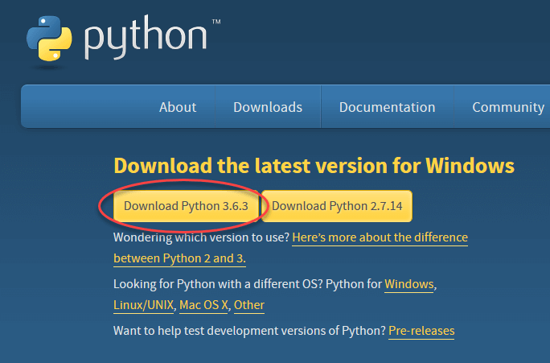](https://www.guru99.com/images/Pythonnew/Python2.1.png)

**Step 2)** Once the download is completed, run the .exe file to install Python. Now click on Install Now.

[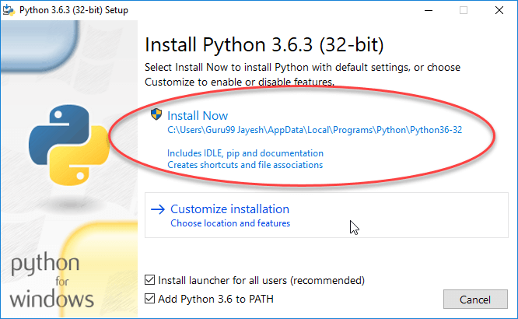](https://www.guru99.com/images/Pythonnew/Python2.2.png)

**Step 3)** You can see Python installing at this point.

[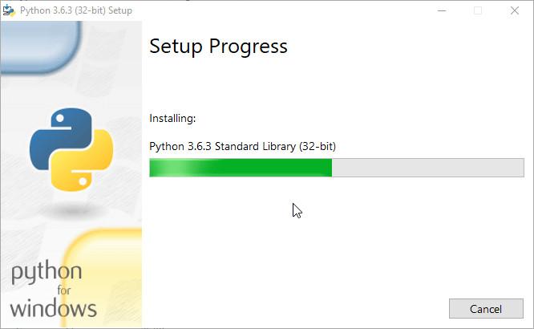](https://www.guru99.com/images/Pythonnew/Python2.3.png)

**Step 4)** When it finishes, you can see a screen that says the Setup was successful. Now click on "Close".

[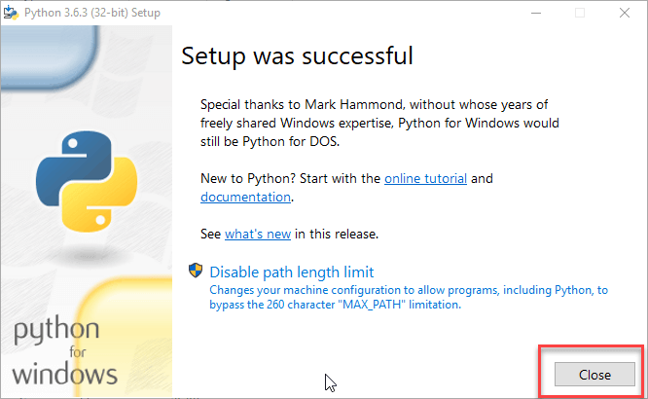](https://www.guru99.com/images/Pythonnew/Python2.4.png)

**Conclusion :** thus we have understood how to install and configure python IDE.